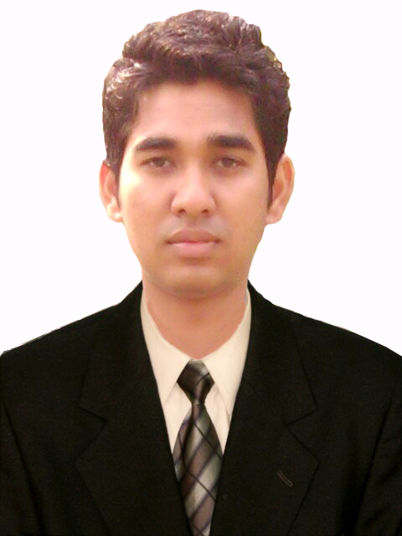
IMRAN AHMAD
E-126, 3rd floor, Gali No.5, Pandav nagar Ganesh nagar Complex, New Delhi-92
Contact No.:+918800288437, E-mail: imranahmad221992@gmail.com

- AREAS OF SPECIALIZATION -
Marketing & Human Resource

OBJECTIVE
I wish to work in a prestigious organization and to obtain a challenging position that allows me to utilize my current skills to assist in advancing a business that offers a stable employment opportunity.

EDUCATION QUALIFICATION

DEGREE | UNIVERSITY/INSTITUTE | MAJOR SUBJECTS | PERCENTAGE/GRADE | YEAR OF PASSING
M.B.A | U.P.T.U | Marketing &HR | Result awaited | 2013-15
B.B.M | MAGADH UNIVERSITY GAYA | Marketing &HR | 62 | 2013
12th | B.S.E.B | Science | 62 | 2010
10th | C.B.S.E | Math, Eng, Sci. | 68 | 2007

SUMMER INTERNSHIP

Company | Project Title | Project Details
TNS India Pvt. Ltd. | Reactions of Customer and Retailers towards Nokia’s first android phone “Nokia X and Nokia XL”. | - Primary & Secondary research done on data collected through surveys in Delhi-NCR region.  - Objective of the study was to see the interest of Customers and Retailers on Phone.

OTHER PROJECTS UNDERTAKEN

- Did 25 Days dual time study as an Auditor of logistics in Cargo Terminal 2 in IGI Airport, Delhi for Delhi International Airport (P) Limited (DIAL).

TECHNICAL SKILLS
- Knowledge of MS Office Applications (word, excel & power point).
- Knowledge of internet.

EXTRA CURRICULAR ACTIVITIES AND INTERESTS

- Active participant in Quiz competition, debate and other cultural activities.
- Organized Farewell party and fresher party of college.

AWARDS AND ACHIEVMENTS

- Got third position in power point presentation competition in college.
- Won prize in debate competition school and college.

PERSONAL DETAILS

Father’s Name
Gender
Marital Status
Languages Known

Present Address

D.O.B
Preferred Location

: Md. Malik Ahmad
: Male
: Unmarried
: English (read, write and speak)
Hindi (read, write and speak)
: E-126, 3rd floor, Gali no.5, Pandav nagar Ganesh nagar complex, New Delhi-92
: 22.March.1992
: Delhi NCR

DECLARATION

“This is to certify that the information furnished above is true and authentic to the best of my knowledge and belief.”

Date:
Place: [IMRAN AHMAD]

